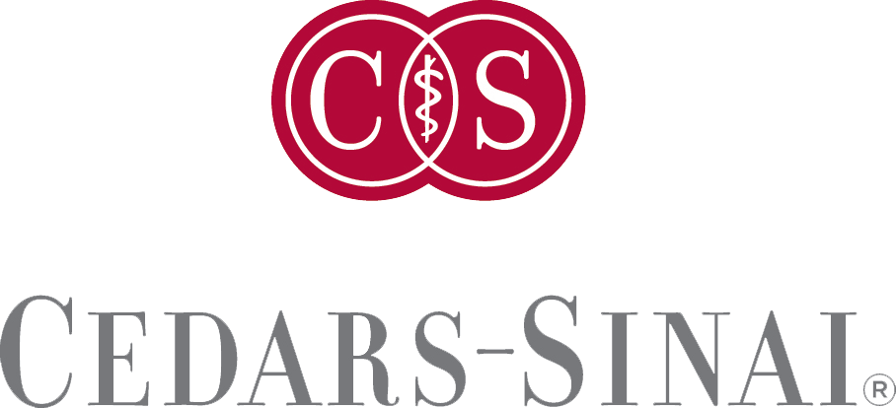
Cedars-Sinai Medical Center presents: Test 2018 Course
Presented by:
Dec 31, 2018 8:00 AM Los Angeles

Topic:
Speakers: «FullName»
Learning Objectives:
Target Audience:
Accreditation Statement: Cedars-Sinai Medical Center is accredited by the Accreditation Council for Continuing Medical Education to provide continuing medical education for physicians.
Cedars-Sinai Medical Center designates this live activity for a maximum of 10.50 AMA PRA Category 1 Credit(s)™. Physicians should claim only the credit commensurate with the extent of their participation in the activity.
Policy on Disclosure: It is the policy of Cedars-Sinai Medical Center to ensure balance, independence, objectivity, and scientific rigor in all of its educational activities. Cedars-Sinai Medical Center assesses conflict of interest with its faculty, planners and managers of CME activities. Conflicts of interest that are identified are resolved by reviewing that presenter’s content for fair balance and absence of bias, scientific objectivity of studies utilized in this activity, and patient care recommendations. While Cedars-Sinai Medical Center endeavors to review faculty content, it remains the obligation of each physician or other healthcare practitioner to determine the applicability or relevance of the information provided from this course in his or her own practice. In accordance with the policy of Cedars-Sinai, faculty are asked to disclose any affiliation or financial interest that may affect the content of their presentations.

Acknowledgement of Commercial Support: Cedars-Sinai Medical Center gratefully acknowledges an educational grant in support of this educational activity from the following company(s):
For questions, call _______________ or email cme@cshs.org.

