Exhibit & Sponsorship Prospectus

CALSIM 2020: The Inaugural Simulation Conference

June 27-28, 2020

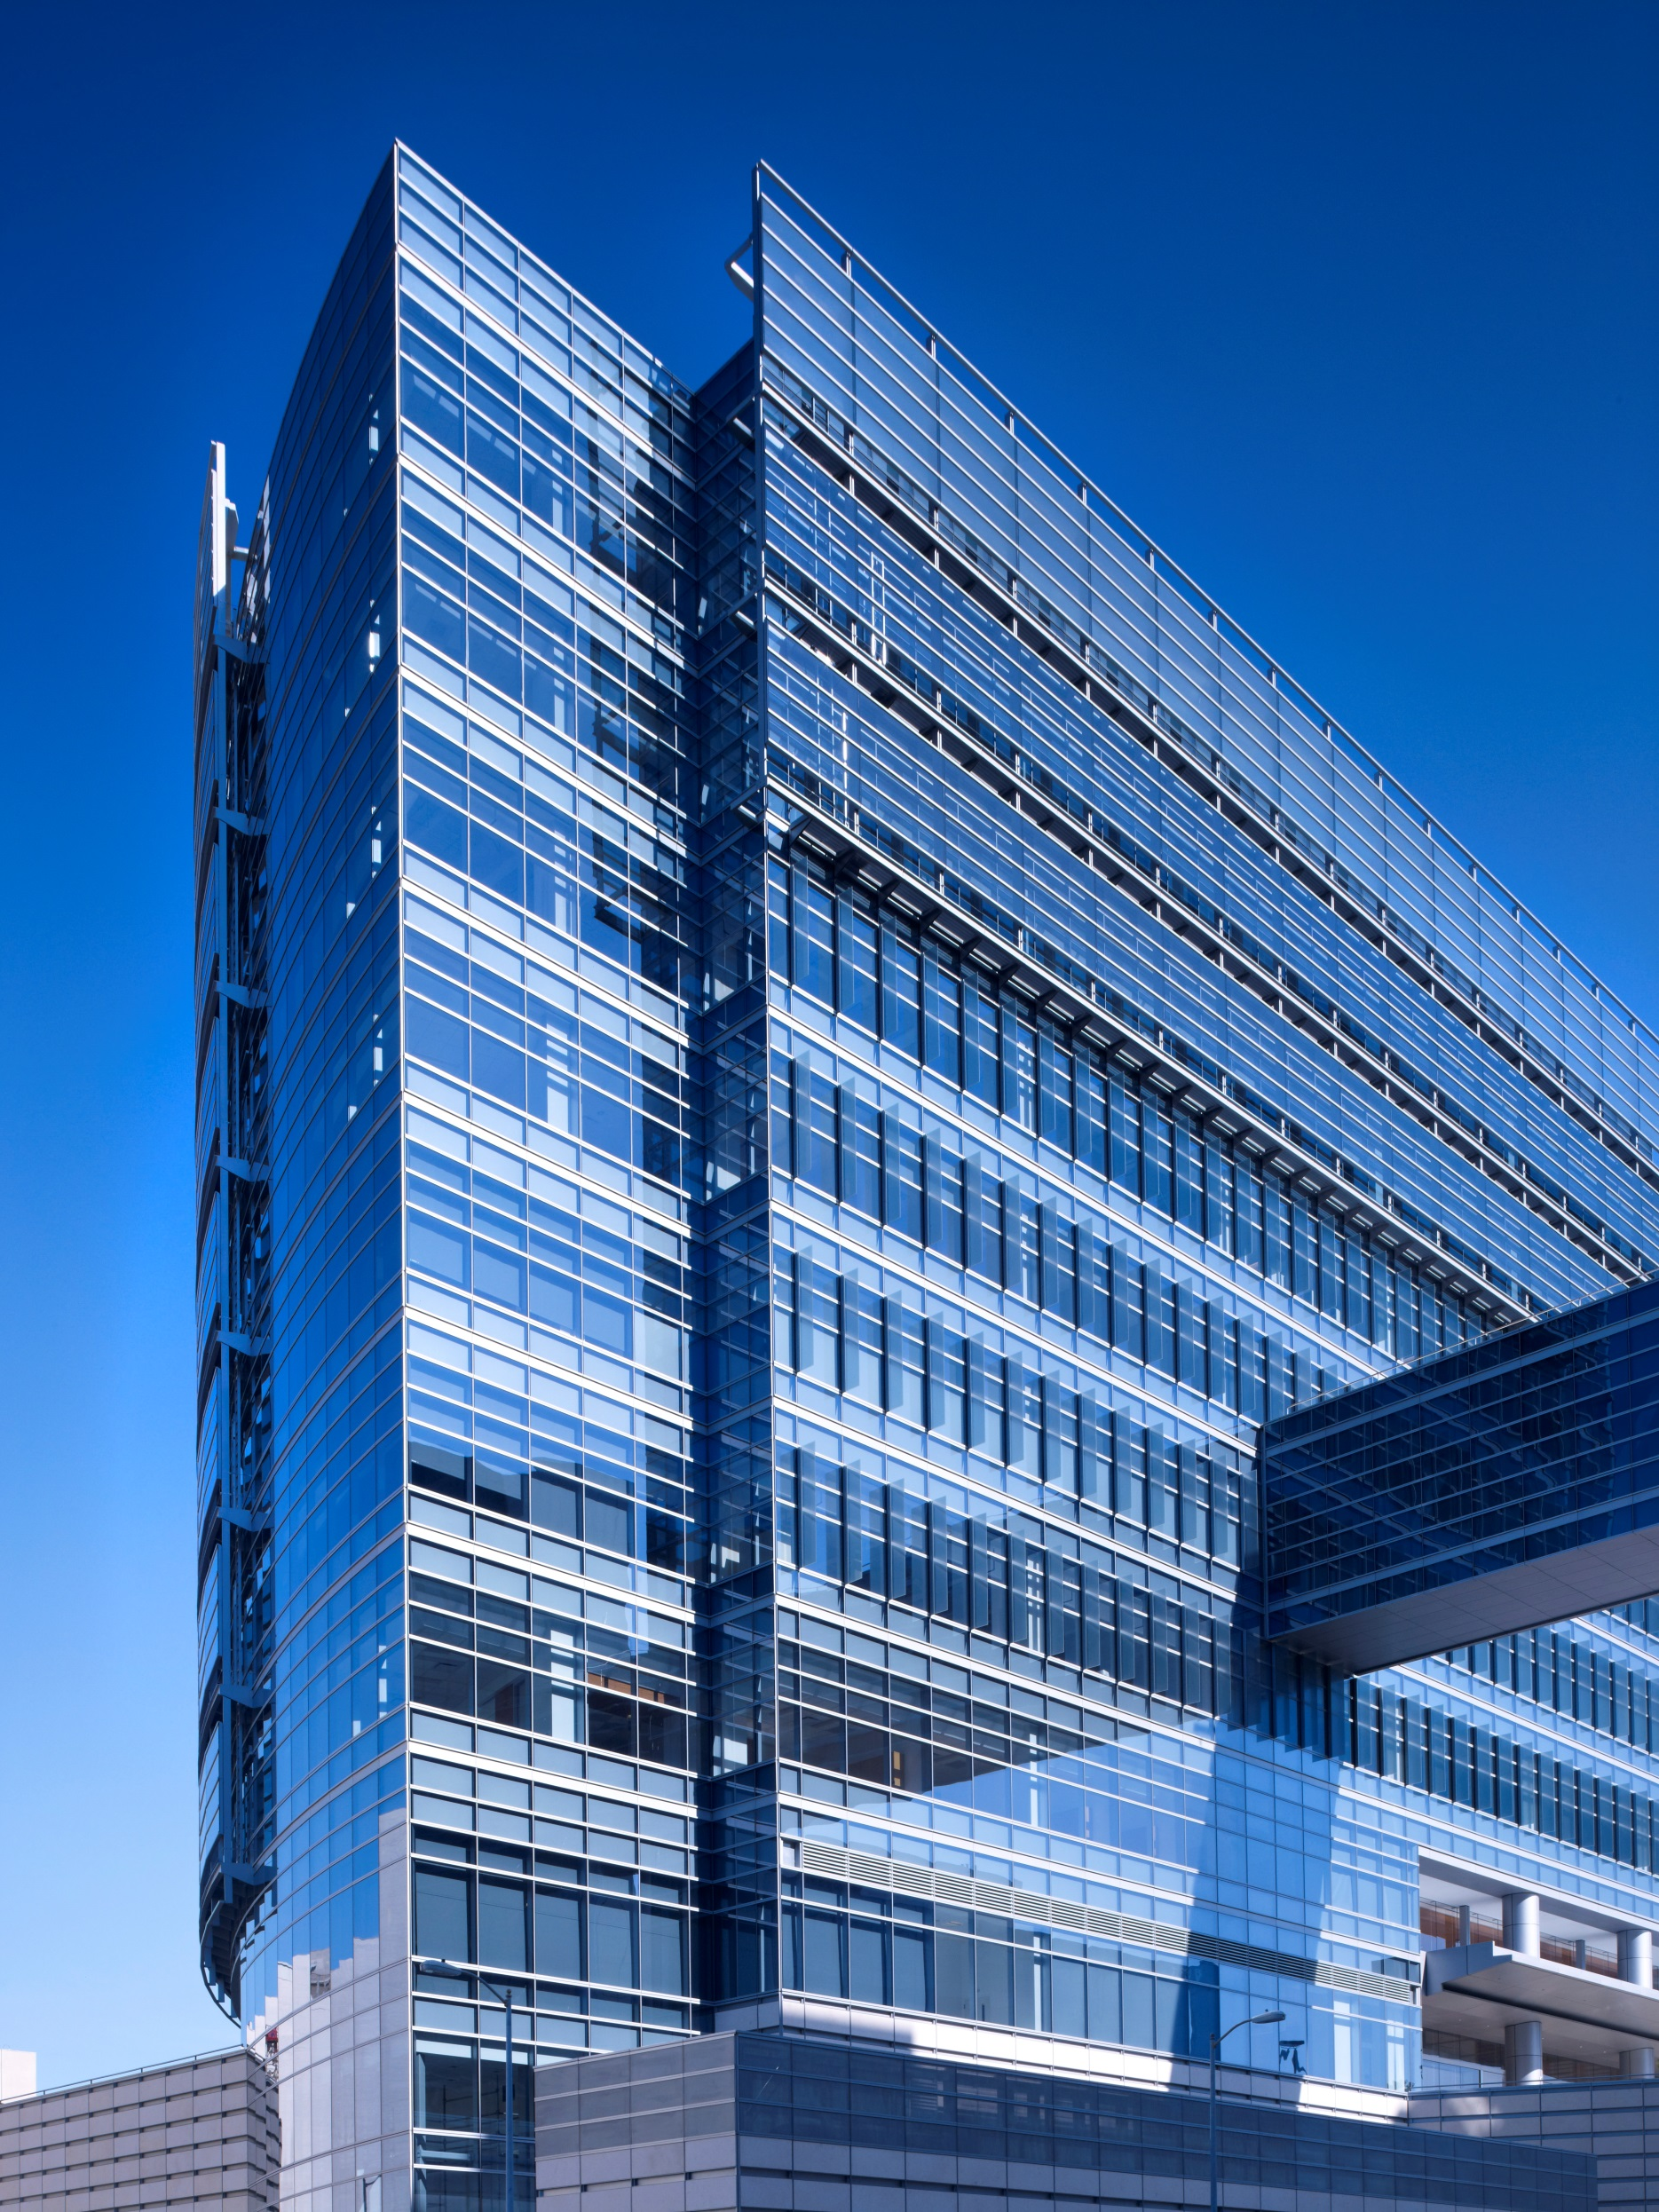

Cedars-Sinai CALSIM 2020:
The Inaugural
This engaging everything-you-need-to-know-about-simulation-based-training will provide participants with evidence-based presentations that explore how simulation can be an innovative tool for learning and training as well as for assessment of performance. Attendees will explore how simulation training can enhance technical and functional expertise, contribute to problem-solving and decision-making skills, and improve interpersonal and communication skills and team based competencies. Breakout sessions offer learners in-depth exploration of simulation design testing, human factors, and interprofessional education, as well as insights into the role simulation can have in infectious disease management and extracorporeal membrane oxygenation (ECMO). Join your colleagues for this 1-1/2 day adventure into the world of simulation and learn how evidence-based practices can be put into action through protocols and collaborative approaches that can then be practiced using simulation scenarios.

Join
Cedars-Sinai CALSIM 2020:
The Inaugural
June 27-28, 2020
WHY EXHIBIT?

Top 5 Reasons Attendees Visit Exhibitors

Cedars-Sinai CALSIM 2020:
The Inaugural
June 27-28, 2020

BOOTH INFORMATION

$25,000  3 Space Available! | $15,000  4 Spaces Available! | $10,000  9 Spaces Available!

QUESTIONS?
Cedars-Sinai CALSIM 2020:
The Inaugural
June 27-28, 2020

RESERVE YOUR

EXHIBIT SPACE TODAY!
Booths are given priority in assigning type and location according to the date the application is received.

Exhibit Registration

Click here to view conference schedule!

Exhibit Days & Hours

Saturday, June 27, 2020 >> 8:00 am–4:30 pm
Sunday, June 28, 2020 >> 8:00 am–12:30 pm

> Exhibitor Move-In: Saturday, June 27, 2020, 6:30 am
> Exhibit Move-Out: Sunday, June 28, 2020, 1:00 pm

Questions?

For all questions related to exhibiting at this conference, please contact

Ani Mardakhanian, MHA
CME Program Manager
P. 310-423-4635
E. ani.mardakhanian@cshs.org

Cedars-Sinai Office of CME
P. 310-423-5548
F. 310-423-0309
E. cme@cshs.org

IMPORTANT DATES
December 1 | Exhibit Registration Portal Opens
June 1  1 | Exhibit Application Deadline
June  8 | Final Setup/Shipment Info Sent to Exhibitors

